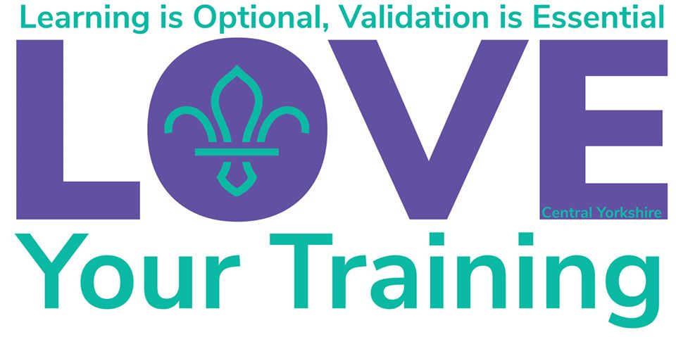

January | Date | Time
 | 11th | 9.30 | Getting Started – Modules 1 and 3 |  | Tingley Scout Hall
 | 11th | 13.30 | Safeguarding |  | Tingley Scout Hall
 | 18th | All Day | First Response – Module 10 |  | Sherburn HQ
 | 18th | All Day | Meeting the Challenges | Managers & Supporters Training | Raywell Park, Humberside
 | 19th | All Day | Achieving Growth | Managers & Supporters Training | Raywell Park, Humberside
 | 18th | All Day | The People – Modules 14 and 15 |  | John Briggs, Bramhope
 | 19th | All Day | The People – Modules 8, 9 and 13 |  | John Briggs, Bramhope
 | 26th | All Day | Presenting and Facilitating - Module 25 |  | County Office
February
 | 1st | All Day | Training for all Appointments – Modules 12A and 12B |  | Sherburn HQ
 | 2nd | All Day | Training for all Appointments – Modules 5, 6, 7 and 11 |  | Sherburn HQ
 | 5th | 19.00 | Safeguarding |  | County Office
 | 8th or 9th | All Day | Nights Away Advisor Workshop
 | 14th | All Day | Meeting the Challenges |  | Tynemouth District HQ
 | 15th | All Day | First Response – Module 10 |  | Sherburn HQ
 | 18th | 19.00 | Getting Started – Modules 1 and 3 |  | Sherburn HQ
 | 24th | 19.00 | Getting Started – Modules 1 and 3 |  | St Chad’s, North Leeds
March
 | 2nd | 19.30 | Nights Away Permit Information Evening |  | County Office
 | 7th | All Day | The Programme Modules 16, 17, 18 and 19 |  | 10th Morley (Drighlington) HQ
 | 12th | 19.30 | Nights Away Permit Information Evening |  | County Office
 | 14th | All Day | First Response – Module 10
 | 18th | 19.00 | Getting Started – Modules 1 and 3 |  | Scholes HQ
 | 24th | 19.00 | Getting Started – Modules 1 and 3 |  | St Chad’s, North Leeds
 | 29th | 9.30 | Getting Started – Modules 1 and 3 |  | 10th Morley (Drighlington)
 | 29th | 13.30 | Safeguarding |  | 10th Morley (Drighlington)
April
 | 4th | All Day | The People – Modules 14 and 15 |  | Sherburn HQ
 | 5th | All Day | The People – Modules 8, 9 and 13 |  | Sherburn HQ
 | 11th | All Day | First Response – Module 10
 | 23rd | 19.00 | Safeguarding |  | County Office
 | 26th | All Day | Achieving Growth | Manager & Supporter Training | Tynemouth District HQ
May
 | 2nd - 3rd | All Day | Skills for Residential Experiences – Module 38 |  | John Briggs, Bramhope
 | 16th | All Day | Skills of Management | Manager & Supporter Training | Moorhouse, Durham
 | 17th | All Day | Skills of Management | Manager & Supporter Training | Moorhouse, Durham
 | 16th | All Day | First Response – Module 10 |  | TBC
 | 17th | All Day | The Programme Modules 16, 17, 18 and 19 |  | 16th Airedale (Yeadon) HQ
 | 18th | 19.00 | Safeguarding |  | TBC

June
 | 13th | All Day | Training for All Appointments Modules 5, 6, 7 and 11 |  | John Briggs, Bramhope
 | 14th | All Day | Training for All Appointments Modules 12A and 12B |  | John Briggs, Bramhope
 | 16th | 19.00 | Safeguarding |  | TBC
 | 27th | All Day | First Response – Module 10 |  | TBC
 | 27th | All Day | Skills of Management | Manager & Supporter Training | John Briggs, Bramhope
 | 28th | All Day | Skills of Management | Manager & Supporter Training | John Briggs, Bramhope
July
 | 19th | All Day | First Response - Module 10 |  | TBC
September
 | 19th | All Day | First Response – Module 10 |  | TBC
 | 19th | All Day | Training for All Appointments – Modules 12A and 12B |  | 8th Wakefield Scouts and Community Centre
 | 20th | All Day | Training for All Appointments - Modules 5, 6, 7 and 11 |  | 8th Wakefield Scouts and Community Centre
 | 26th | All Day | Achieving Growth | Manager & Supporter Training | John Briggs Centre, Bramhope
 | 27th | All Day | Achieving Growth | Manager & Supporter Training | John Briggs Centre, Bramhope
 | TBC | 9.30 | Safeguarding |  | TBC
 | TBC | 13.30 | Getting Started – Modules 1 and 3
October
 | 3rd |  | Getting Started – Modules 1 and 3 |  | TBC
 | 10th | All Day | The Programme - Modules 16, 17, 18 and 19 |  | Sherburn HQ
 | 11th | All Day | Assessing learning - Module 25 |  | TBC
 | 24th | All Day | First Response – Module 10 |  | Templars HQ
November
 | 14th | All Day | The People – Modules 8, 9 and 13 |  | Templars HQ
 | 15th | All Day | The People – Modules 14 and 15 |  | Templars HQ
 | 22nd | All Day | First Response – Module 10 |  | TBC
 | tbc | am | Getting Started – Modules 1 and 3 |  | TBC
 | TBC | pm | Safeguarding |  | TBC
December
 | 5th | All Day | Training for All Appointments – Modules 5, 6, 7 and 11 |  | Shire Oak
 | 6th | All Day | Training for All Appointments – Modules 12A and 12B |  | Shire Oak
 | 12th | All Day | First Response – Module 10 |  | TBC

For further details:
alison.fell@cycscouts.org.uk

